**Video Analytics for PPE Detection**

**- A PPE Detection System -**

**Beta Version**

User Manual



Sponsored by TIEFA

# 1.0 - General Information

In this document, you will learn about the many features available in this web application.

## 1.1 - System Overview

This web application titled **‘Video Analytics for Personal Protective Equipment’,**​uses video​ analytics and Artificial Intelligence to detect Personal Protective Equipment worn by visitors’ to the ECTC pilot plants, and assess their compliance with PPE safety regulations. In the event of a violation, the result will be logged in the database and the Safety Manager notified of the violation through Slack and the dashboard.

The web application consists of two parts:

* **Safety Manager Dashboard**

The safety manager dashboard provides a way for safety managers to get an overview of PPE violations, configure detection and notification settings, and manage the detection logs all in one app.

* **Visitor Console**

The visitor console provides an interface for safety managers to configure the camera settings before launching a detection process within the same app. This detection process will contain a Graphical User Interface (GUI) that visitors can interact with to check for PPE compliance. The equipment that the system will detect is based on the PPEs selected by the safety manager in the Safety Manager Dashboard. The results from the detection will be logged into the database and if the result was a violation, a notification will be sent to the safety manager through Slack.

## 1.2 - Organization of the Manual

This user manual consists of two sections: General Information and Using the System.

**General Information**  is a brief description and overview of the web application and what the application contains.

**Using the System**  is a brief guide on each feature of the application, inclusive of screenshots, explanation and desired outcome.

# 2.0 - Using the System

## 2.1 - Safety Manager Dashboard

This section covers the Safety Manager Dashboard. Please ensure that the web application is installed by following the **Installation Manual**​ .​

### 2.1.1 - Dashboard

The dashboard provides the user an overview of the detection system. The overview contains the total violation logs, types of PPE violations in the past week, live camera feed and PPEs being detected.

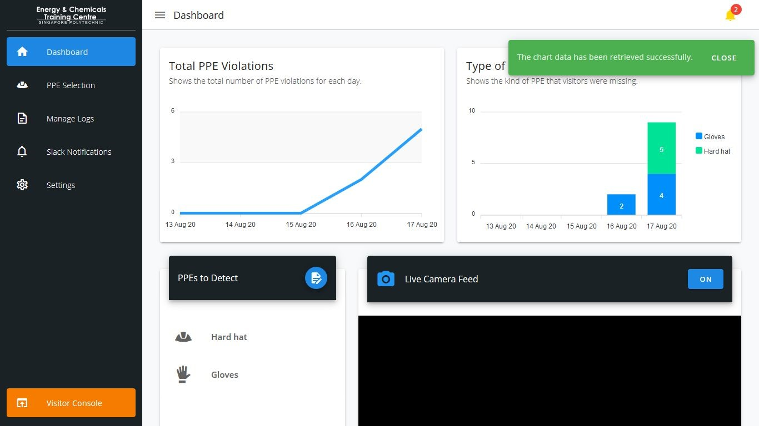

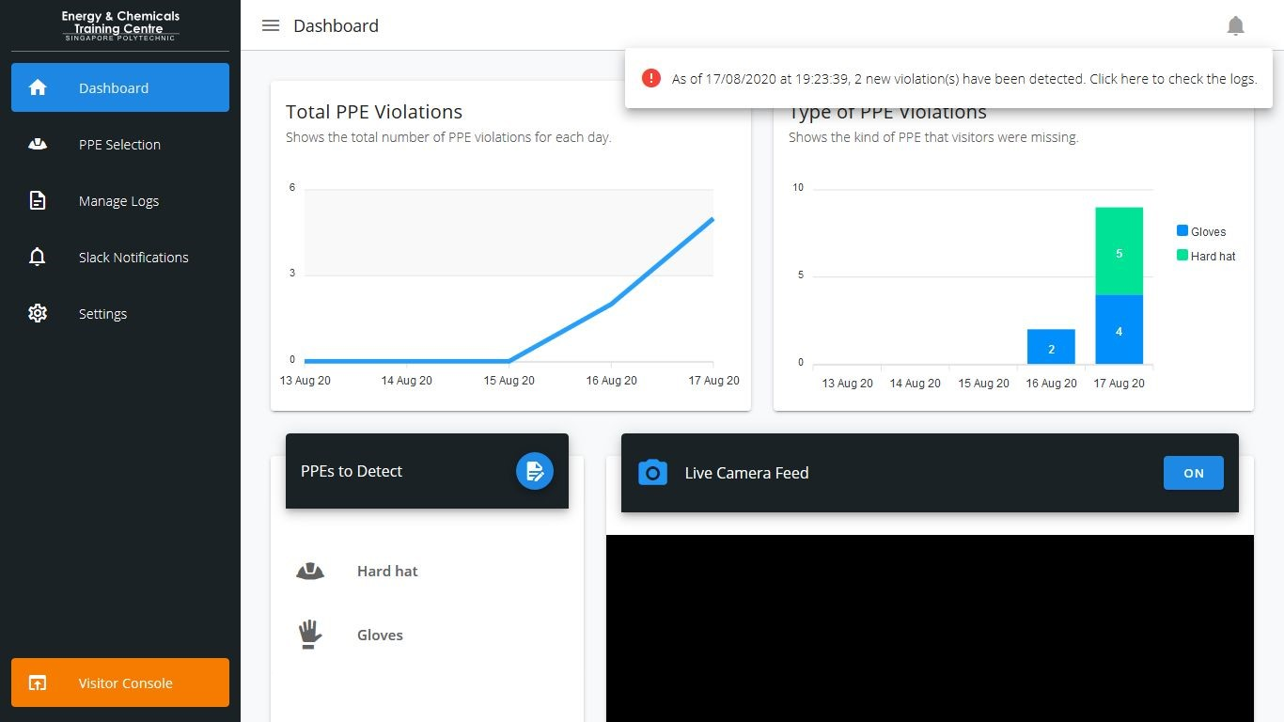

**Total PPE Violations:** Shows the trend of violations over the course of five days (four days ago​ until today).

**Type of PPE Violations:** Shows the number of times an equipment has been violated over the​ course of five days (four days ago until today).

**PPEs to Detect:** Shows the list of PPEs that will be detected when a user uses the visitor app.​

**Live Camera Feed:** Shows a live feed from a connected webcam. You can turn on or off the​ camera feed by clicking on the respective “ON/OFF” button on the right. (**NOTE:**​ You will have​ to grant access to your camera in the browser for this feature to work)

**Bell:** Shows a notification when a new record has been created. (refer to Figure 1).​

Clicking on the bell icon will show a message about the number of new records, and clicking on it again will dismiss it (refer to Figure 2).

**Navigation Sidebar:** Used to navigate to the various features of the application​

* **Dashboard:** Provides an overview of the detection system.​
* **PPE Selection:** Choose the Personal Protective Equipment to detect.​
* **Manage Logs:** View and delete any logs in the database.​
* **Slack Notifications:** Manage and delete the access tokens and channel IDs for the​ Slack workspace.
* **Settings:** Configure the application settings such as importing and exporting of database​records.
* **Visitor Console:** Opens the Visitor Console in a new tab​

### 2.1.2 - PPE Selection

This feature is used to select the Personal Protective Equipment that the system will detect during the detection process.

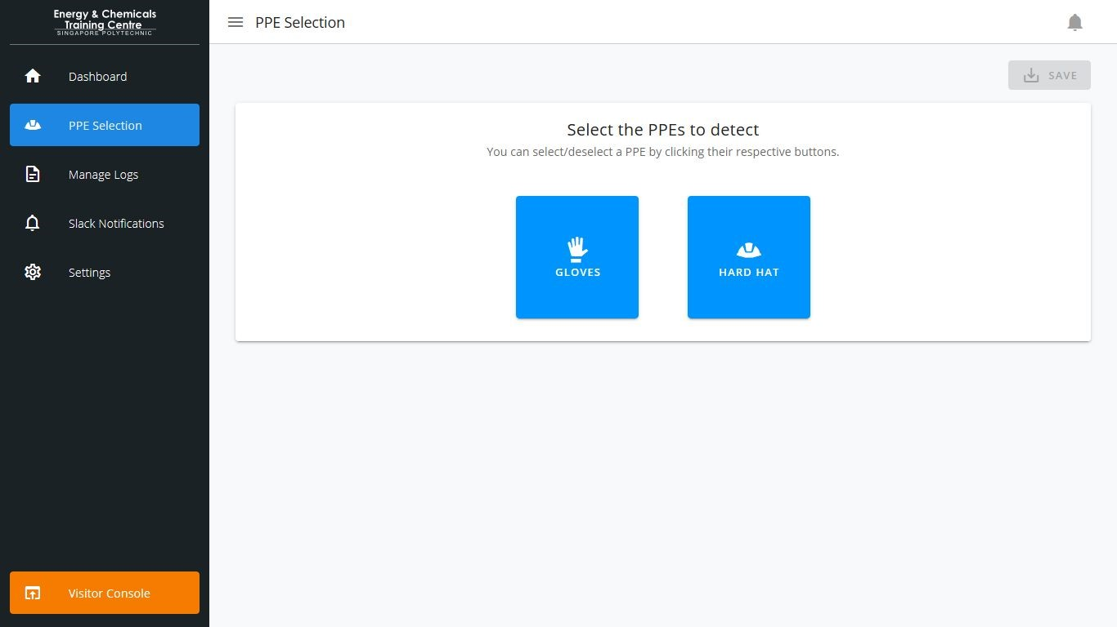

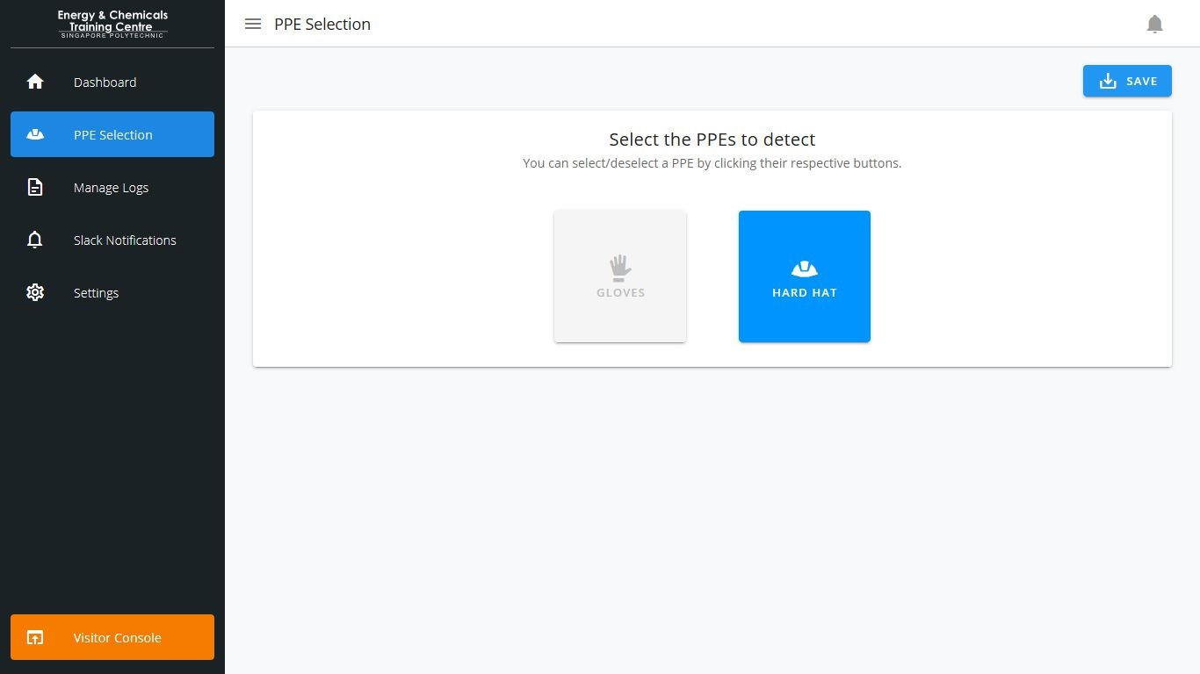

**Select the PPEs to detect:** Shows a list of PPEs to choose from (Refer to Figure 3).​

**Save:** Saves any changes into the database (Refer to Figure 4).​

**● Success:** A success message would appear as a popup in green​  **● Failure:** A failure message would appear as a popup in red.​

### 2.1.3 - Manage Logs

This feature is used to manage the detection logs stored in the database. Logs can be filtered by selecting from a list of options provided and can be deleted if necessary.

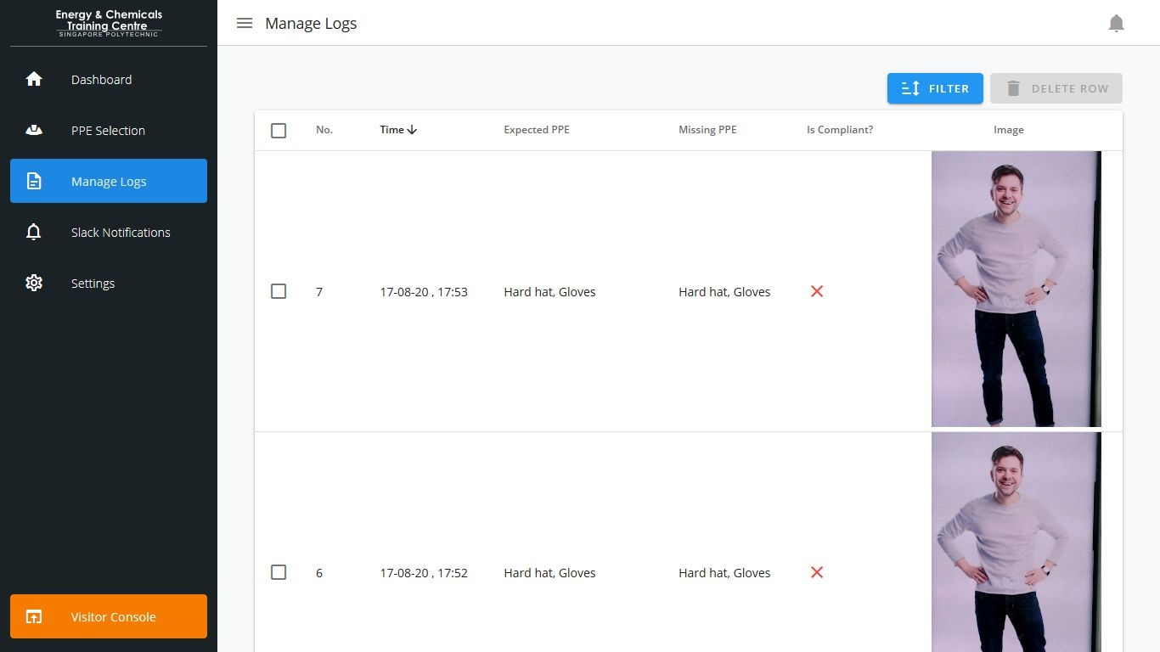

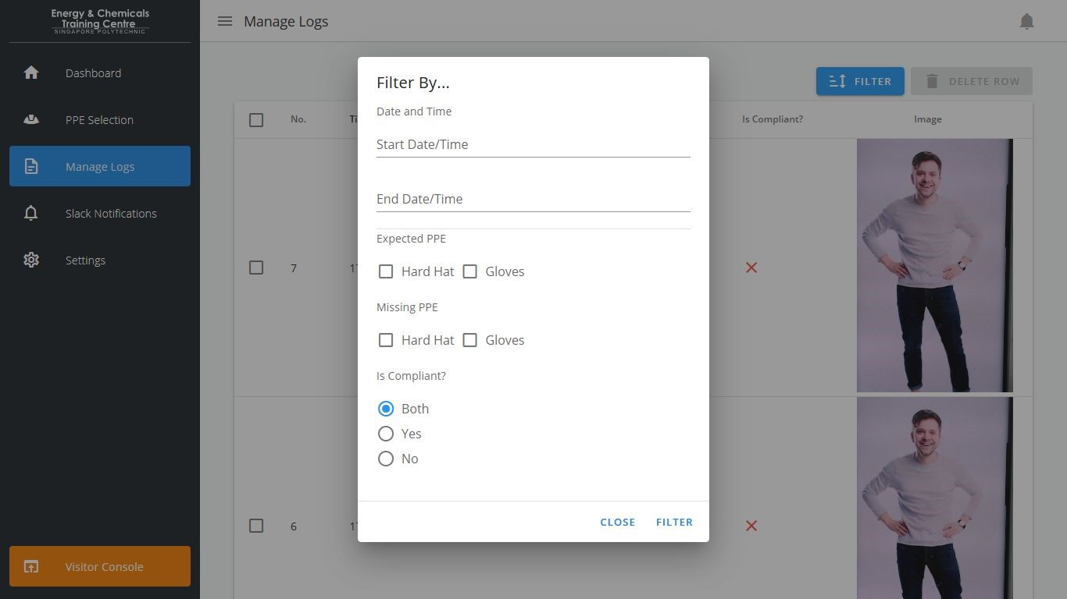

**Logs Table:** ​A list containing all records detected.(Refer to Figure 5)

● **No.:** ​The record number.

* **Time:** ​Date and timestamp of the record.
* **Expected PPE:** ​A list of PPE expected for the day.
* **Missing PPE:** ​A list of PPE that was missing during detection.
* **Is Compliant?:** ​A checkmark/cross stating the compliance of a visitor.
* **Image:**​ The image of the visitor at time of detection.

**Filter:** ​Hide/unhide logs based on a selected criteria. (Refer to Figure 6)

* **Date and Time**
* **Start Date/Time:** ​Shows all records created after the date and time specified.
* **End Date/TIme:** ​Shows all records created before the date and time specified.
* **Expected PPE/Missing PPE** 
  1. **Hard Hat:** Shows all records that include only the Hard Hat.​

○ **Gloves:** Shows all records that include only the Gloves.​

* **Is Compliant** 
  1. **Both:** Shows both compliant and non-compliant records.​

○ **Yes:** Shows all compliant records.​

○ **No:** Shows all non-compliant records​

**Delete Row:** Deletes a record based on selected values.​

### 2.1.4 - Slack Notifications

This feature is used to manage the slack workspace. The user can add new OAuth access tokens and channel IDs. Users can assign and unassign existing channels and OAuth access tokens.

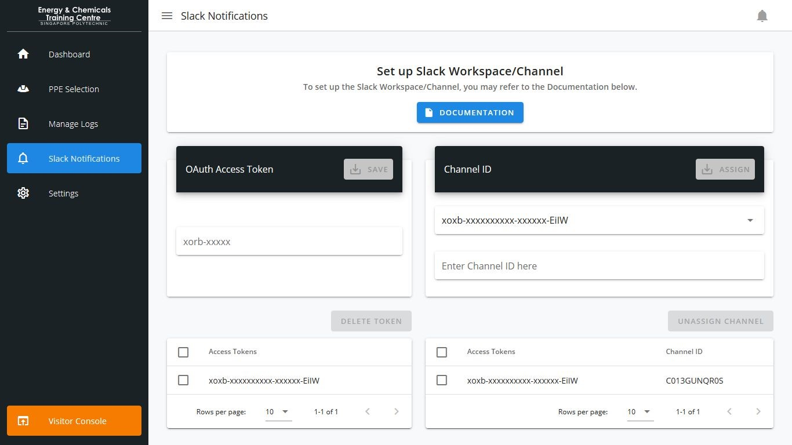

**Set up Slack Workspace/Channel:** Contains a downloadable documentation to set up the workspace/channel for Slack (Refer to Figure 7).

**OAuth Access Token:** Add a new OAuth Access Token (Slack bot)*​

**Channel ID:** Link a channel ID to an existing OAuth Access Token*​

**Access Token Table:** View and manage their access tokens. The ‘Delete Token’ button will be​ enabled

**Channel ID Table:** View and manage Channel IDs linked to their respective access tokens​

* Please refer to the documentation to set up your Slack workspace/channel

### 2.1.5 - Settings

This feature allows the user to import and export logs using CSV

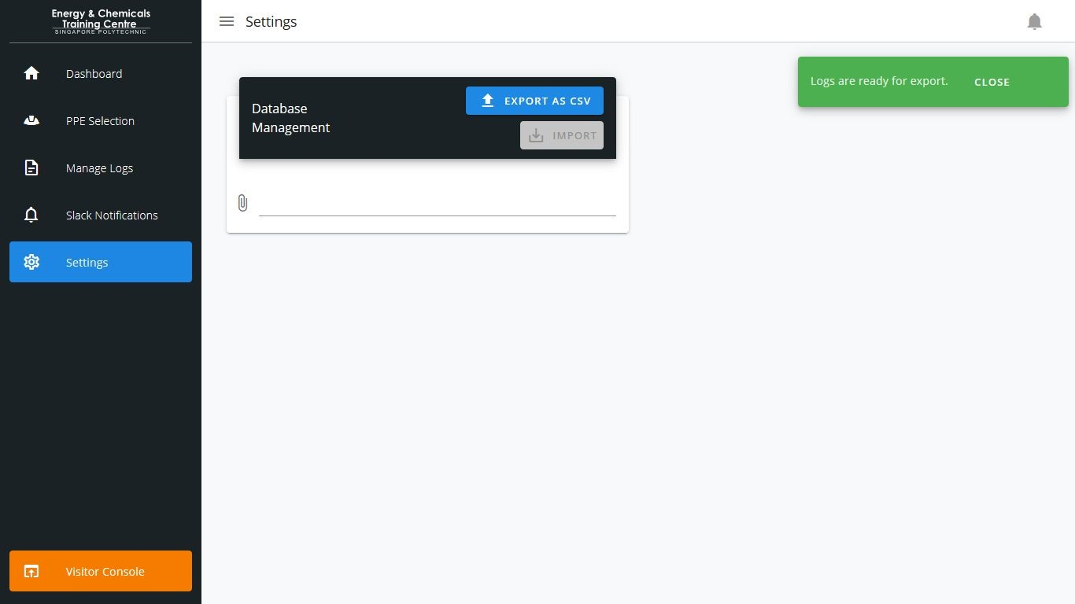

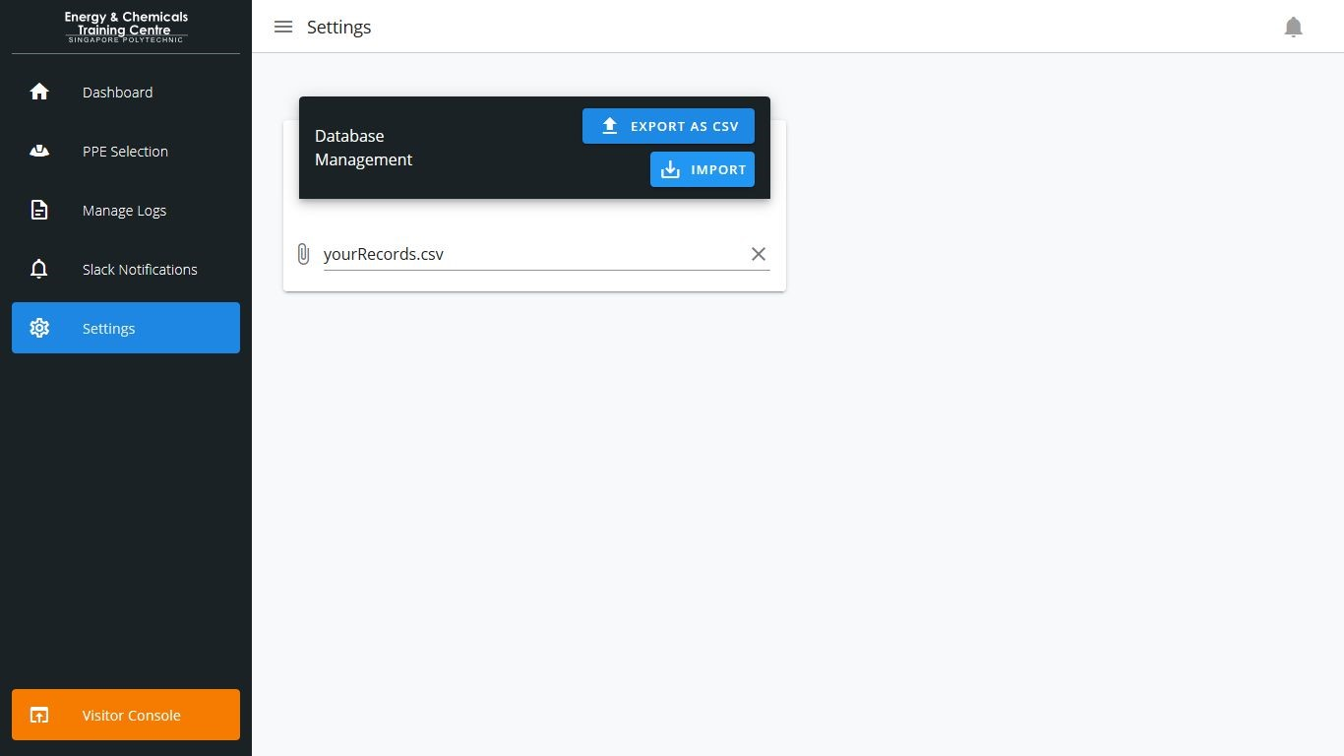

**Export As CSV:** Gathers all your database records and exports them to a .CSV file (Refer to​ Figure 8).

**Import:** Uploads the contents in the .CSV file into the database (Refer to Figure 9).​

* **Success:** A success message would appear as a popup in green.​
* **Failure:** A failure message would appear as a popup in red.

**Troubleshooting Steps:**

* Please ensure that the file used for import is of a valid format (.csv).
* Check that the values on the first row match these: image, time, objectsDetected, objectsViolated, id, compliant.
* Check that none of the cells in the file are empty.

## 2.2 - Visitor Console

This section covers the Visitor Console. Please ensure that the web application is installed by following the ​**Installation Manual**​.

### 2.2.1 - Main Page

This feature allows the safety manager to edit the camera configuration.

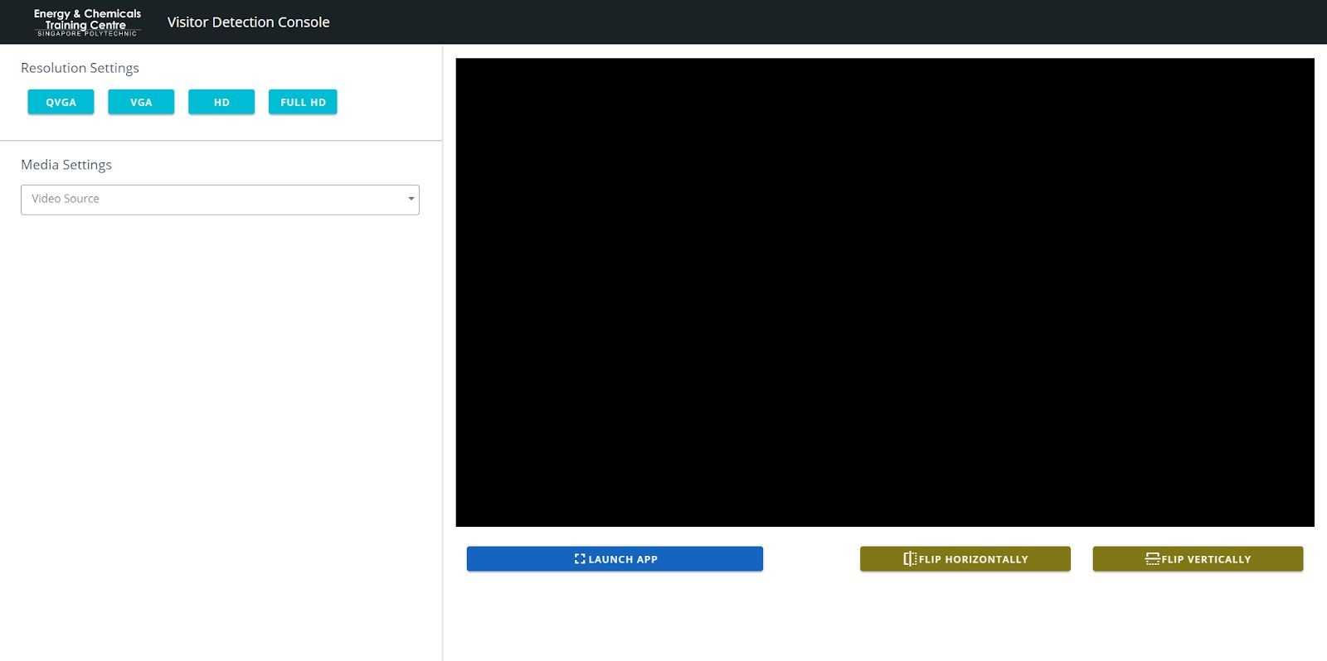

**Resolution settings:** ​Set the resolution for the camera output.

**Media Settings:** ​Set the Audio Input device and Video Source for the Visitor Console.

**Launch App:** ​Launches the PPE Detection App.

**Flip Horizontally:** ​Flips the video feed horizontally.

**Flip Vertically:** ​Flips the video feed vertically.

### 2.2.2 - PPE Detection App

This feature allows the visitor to conduct PPE compliance detection.

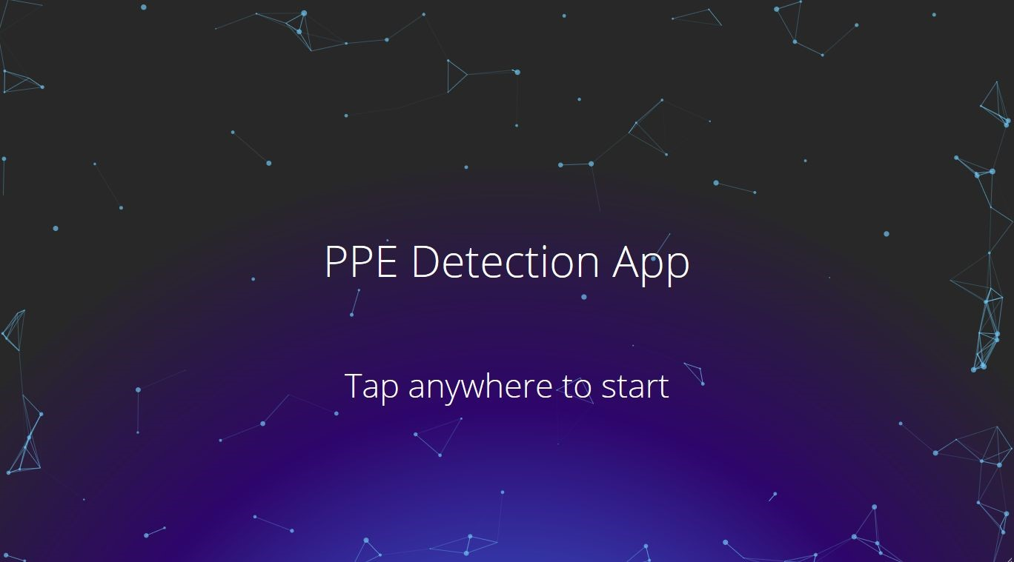

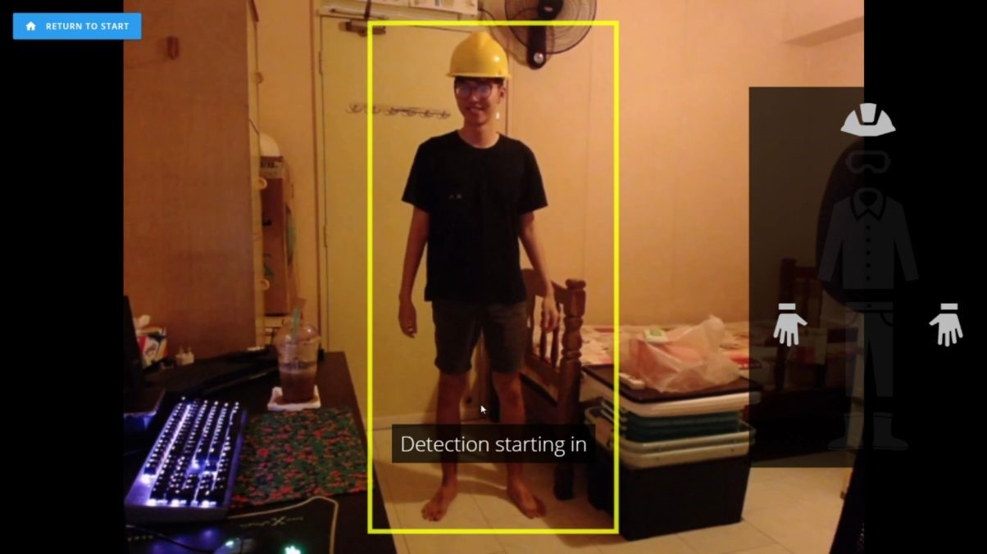

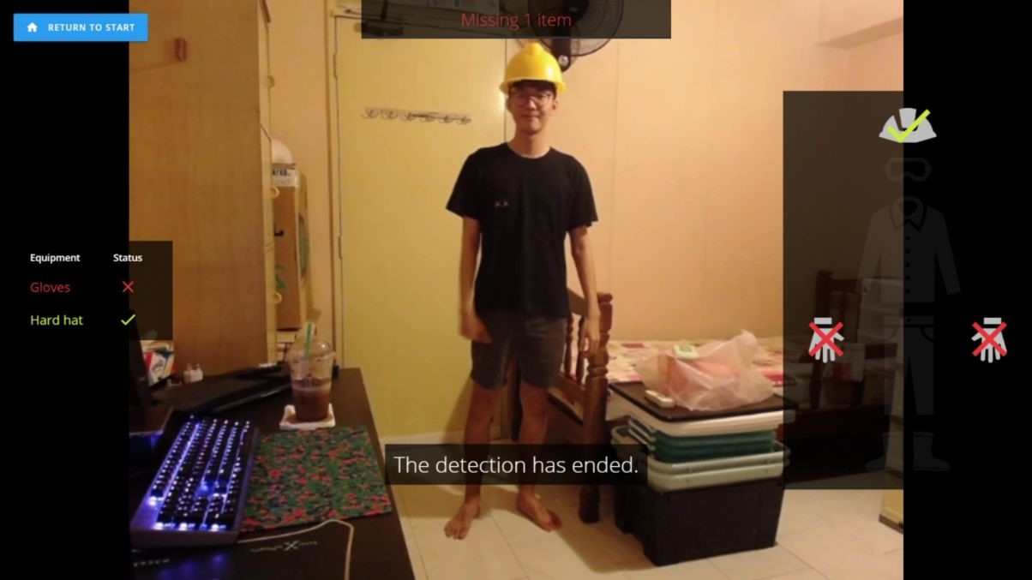

**Start Screen:** ​Tap the screen to start the PPE detection process (Refer to Figure 11).

**Detection Screen:** ​The detection process will begin when a visitor steps into the designated yellow box. A voice over will guide the user through the detection process (Refer to Figure 12, 13).

* **Left Panel:** ​Notifies the user if there is someone in the box.
* **Right Panel:** ​Shows the PPE required for detection for the day.
* **Return to Start:** ​Returns to the Start screen.

## 2.3 - Updated Visitor Console (as of 27 January 2022)

This section covers the Visitor Console. Please ensure that the web application is installed by following the ​**Installation Manual**​.

### 2.3.1 - Main Page

This feature allows the safety manager to edit the camera configuration.



**Resolution settings:** ​Set the resolution for the camera output.

**Media Settings:** ​Set the Audio Input device and Video Source for the Visitor Console.

**Launch App:** ​Launches the PPE Detection App (goes into fullscreen).

**Flip Horizontally:** ​Flips the video feed horizontally.

**Flip Vertically:** ​Flips the video feed vertically.

### 2.3.2 - PPE Detection App

This feature allows the visitor to conduct PPE compliance detection.

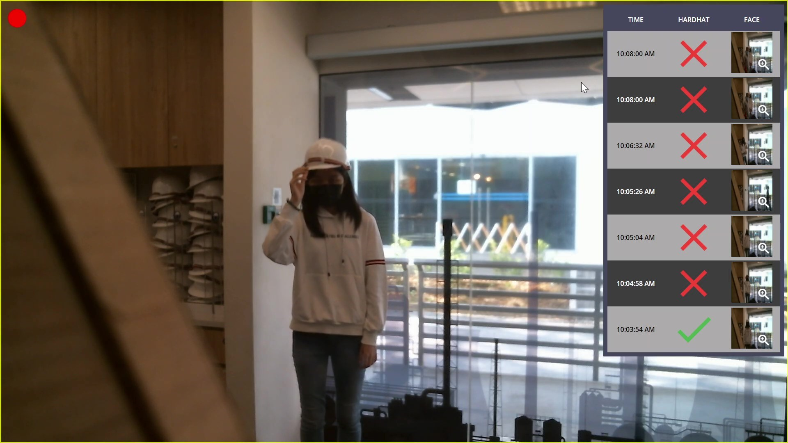

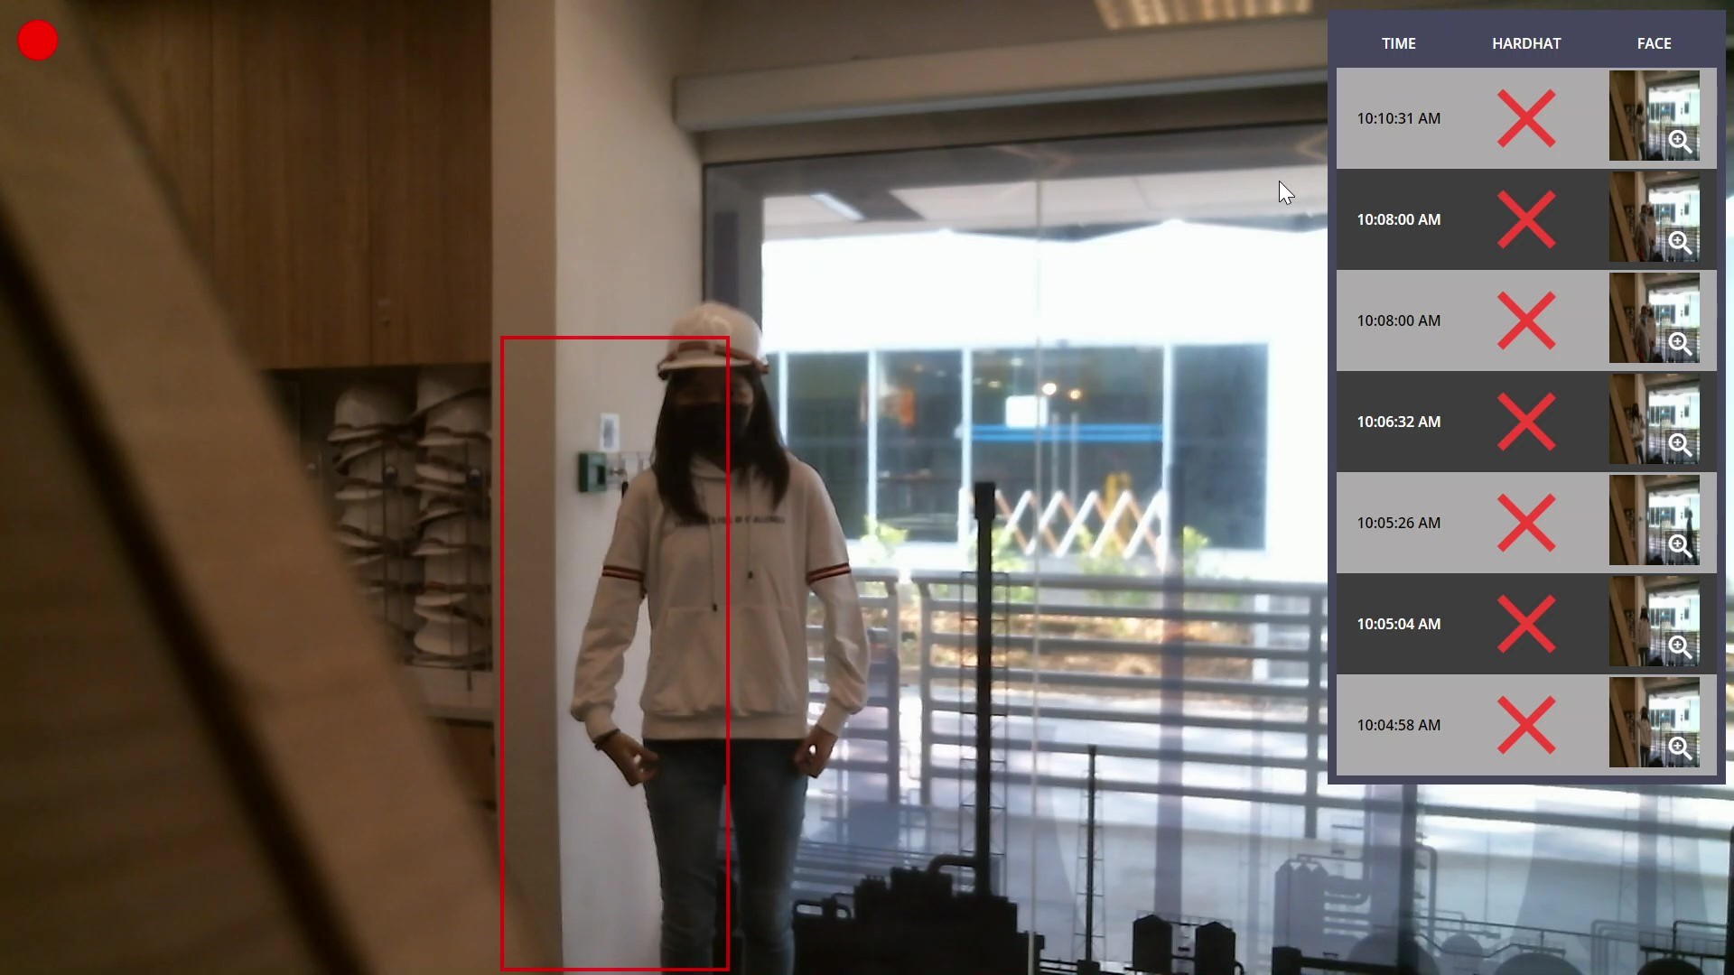

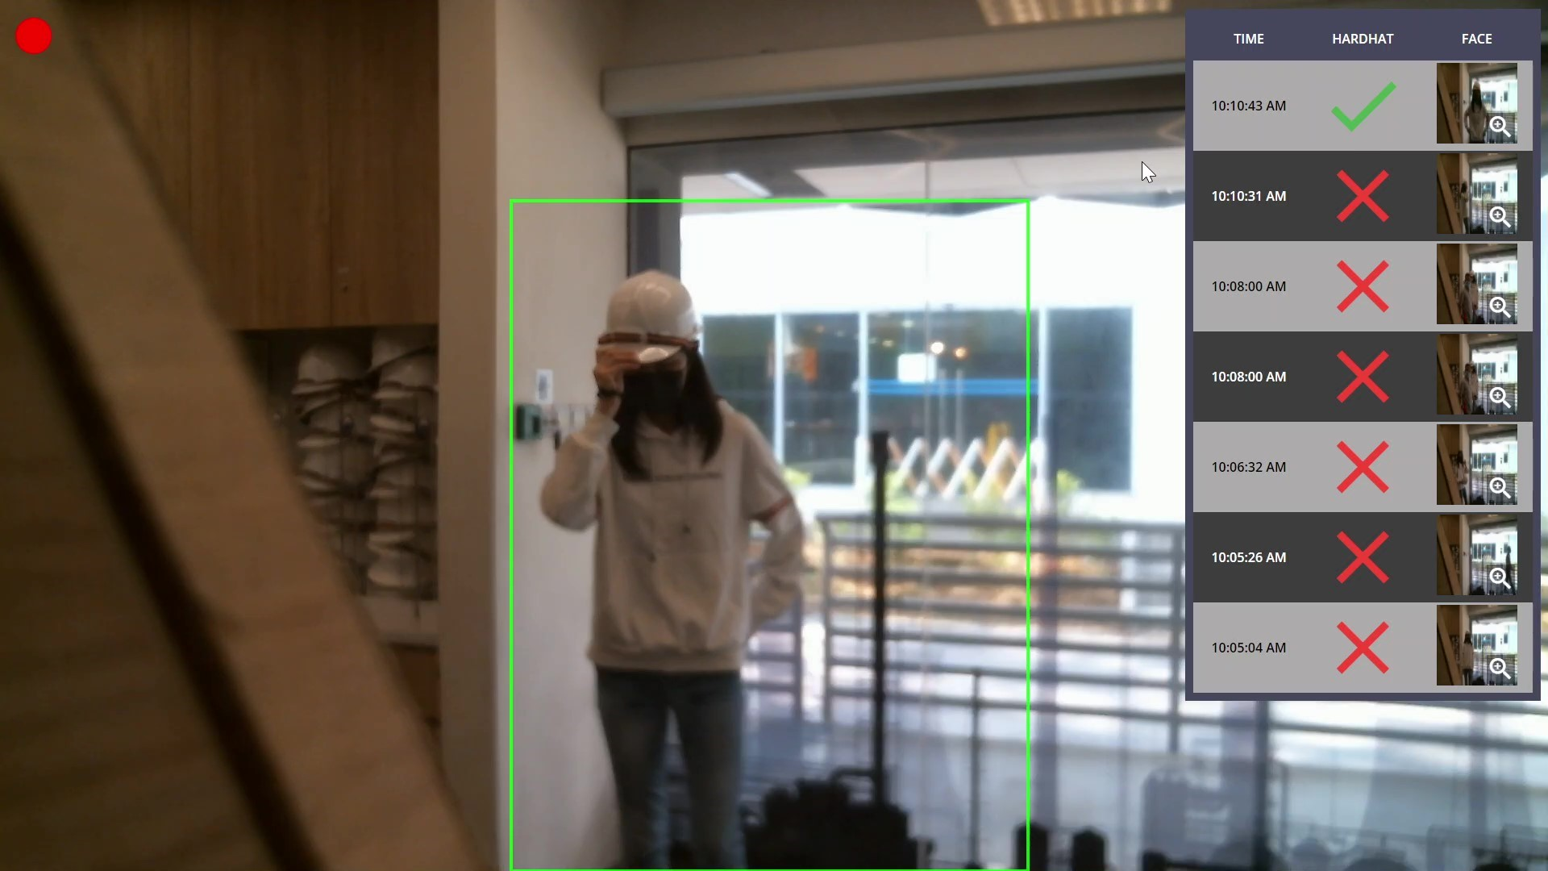

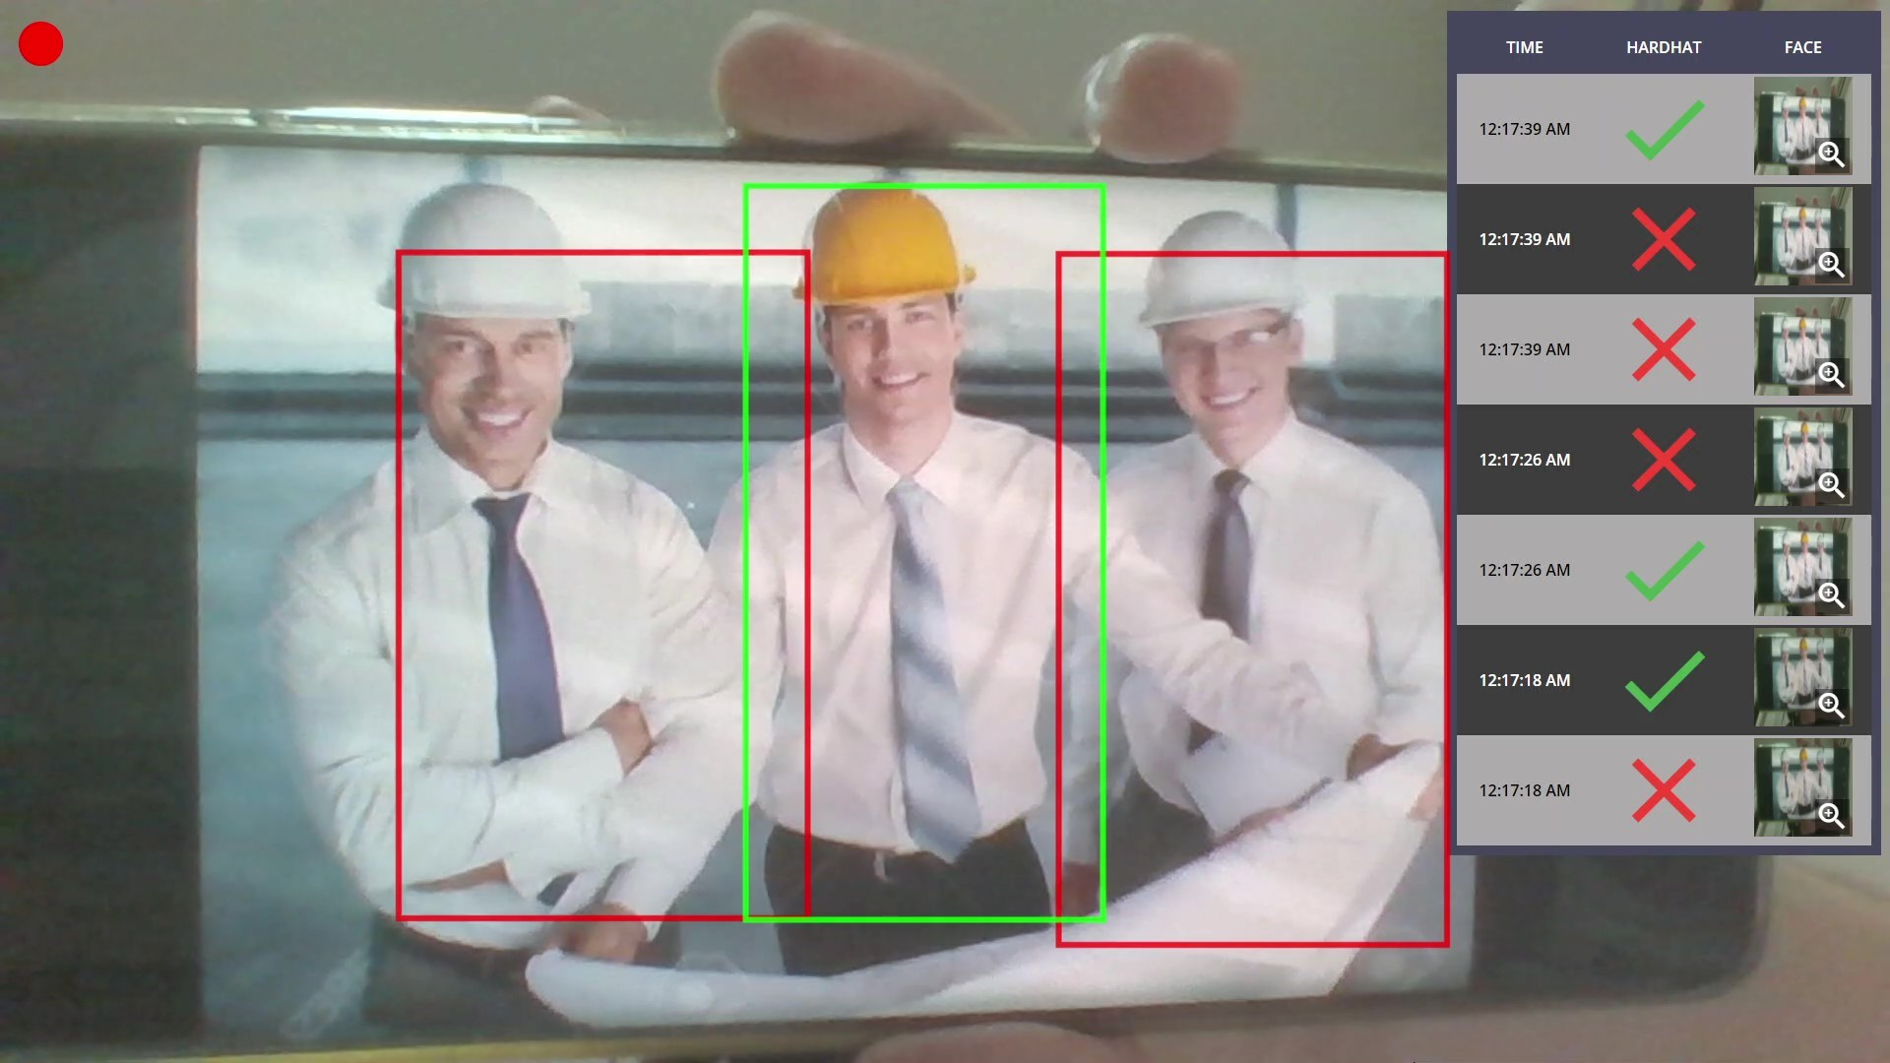

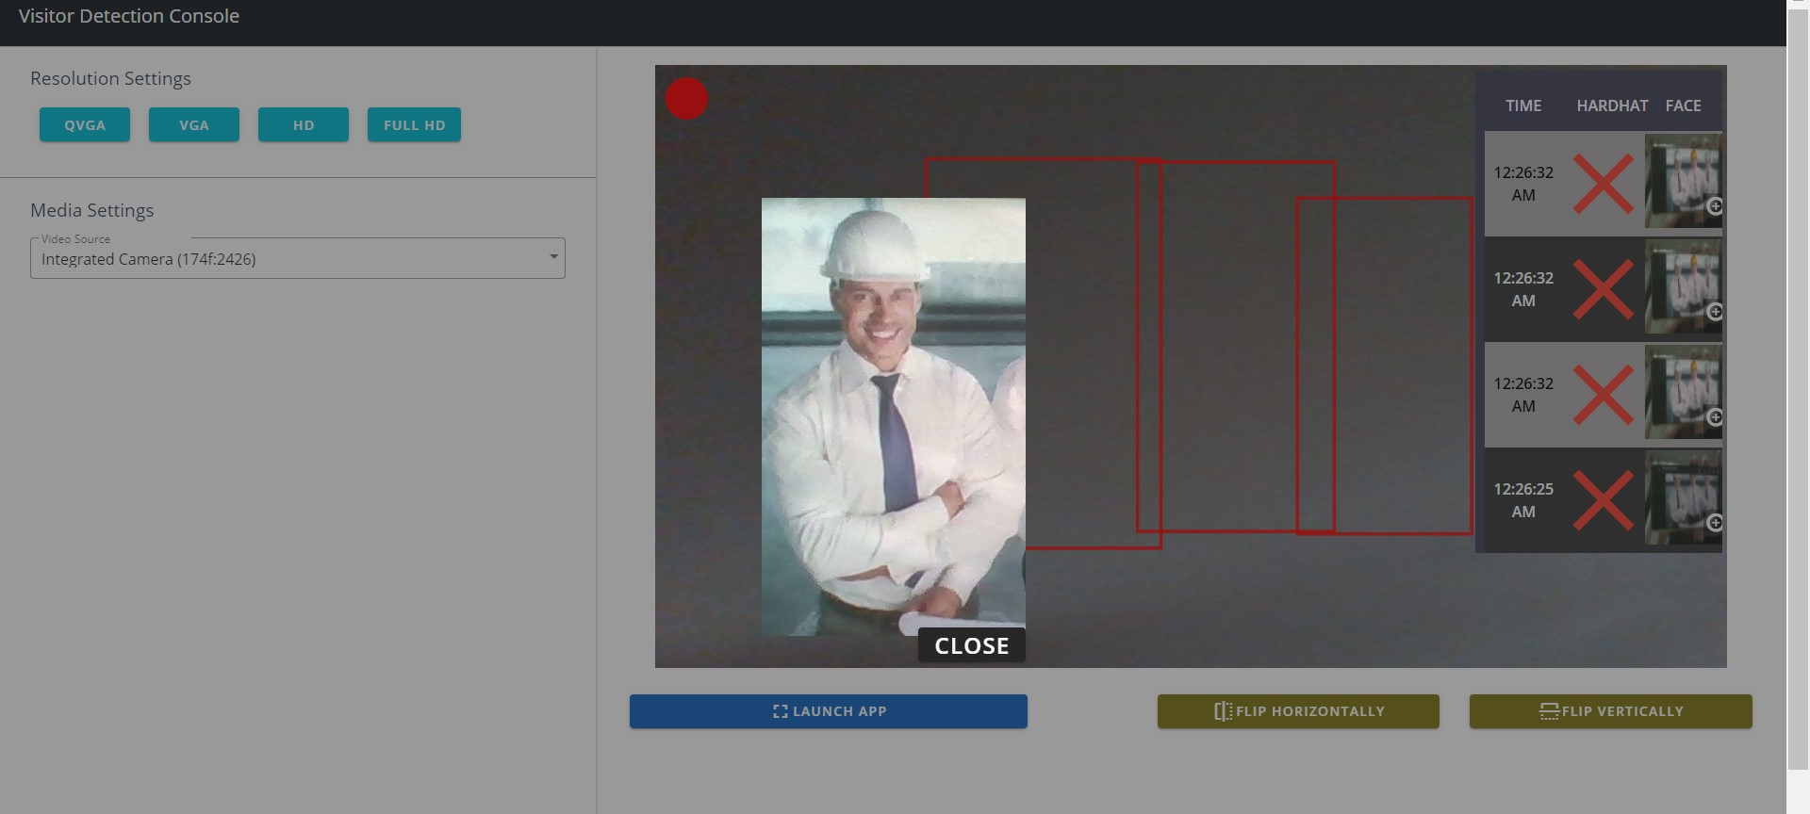

**Changes Made:**

* **Removed**: Start Screen, Detection Screen, "Return to Start" button and most text-to-speech voices.
* **Detection Process**: Immediately starts once person is detected. Once detection is done, a boundary box is drawn on the person depending on whether a hardhat is detected: red outline for no hardhat, green outline for hardhat detected. If no hardhat is detected, there will be a voiceover indicating non-compliance detected. The detection process automatically repeats and will run continuously until the user has exit fullscreen. It is also able to detect multiple people simultaneously.
* R**esults**:A panel showing the last 7 results will be shown on the rightside of the screen, showing the time, presence of hardhat and an image of the person that was captured at the time that the detection was made. All images shown in this panel can be clicked to show the enlarged image.

Note that while showing the enlarged images, the detection process still runs in the background.

* **Non-compliance Indicator**: In conjunction with the results panel, there will be a dot present in the top left corner of the screen. This dot indicates whether there are noncompliant results (no presence of hardhat) out of the 7 results shown in the results panel.

The dot will be shown as red if there is at least 1 out of the 7 results that is non-compliant. The dot will will be shown as green if all 7 results are compliant.

**Troubleshooting**

* **Detection Process**: When the detection process is running, it is indicated by a yellow border around the screen and disappears when it is logging the result and when it is showing the result for a few seconds before the next detection takes place. However, in the case where this yellow border does not appear, has not made a detection for a while, or there is a stray boundary box outline on the screen that does not go away for a while - it can be fixed by re-launching the app by exiting fullscreen and launching the app to go into fullscreen again.